First Aid for Youth Mental Health Qualification Level 2

OFQUAL and RQF

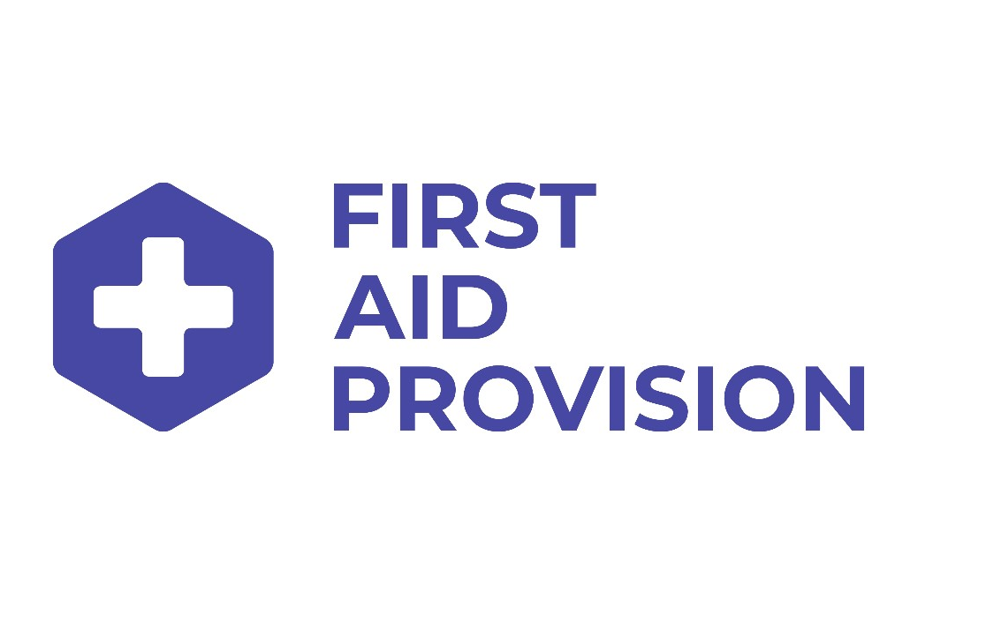

Index

Content

Index
Learning outcomes
Session plan
Module 1 Introduction
Module 2 What is first aid for youth mental health?
Module 3 Identifying mental health conditions
Module 4 Stress
Module 5 Mental health conditions
Module 6 First aid action plan for mental health
Module 7 Assessment and course closure

Learning Outcomes

FAA Level 2 Award in First Aid for Youth Mental Health (RQF) Award in First Aid for Youth Mental Health at SCQF Level 5
Unit title | Youth First Aid for Mental Health
Qualification codes | RQF 603/0911/8 | SCQF R680 04
Unit codes | RQF K/615/4246 | SCQF UP35 04

Learning Outcome | Assessment Criteria
1. Know what mental health is, why young people develop mental health conditions and the role of a First Aider for mental health | 1.1 Define mental health
 | 1.2 Indicate understanding of the stigma surrounding youth mental health
 | 1.3 Identify factors that can affect a person’s mental health
 | 1.4 Understand the role of a First Aider for mental health
2. Know how to recognise and manage stress | 2.1 Identify signs of stress in students
2. Know how to recognise and manage stress | 2.2 State how stress can be managed
3. Know how to recognise a range of mental health conditions | - Identify signs and/or symptoms for the following mental health conditions:  - Depression  - Anxiety  - Psychosis  - Eating disorders  - Suicide  - Self-harm  - Post-traumatic stress disorder
4. Understand the first aid action plan for mental health and be able to put it in place | 4.1 Demonstrate the application of the first aid action plan for mental health
 | 4.2 Know when to contact the emergency services in respect of first aid for mental health

Session Plan

Module 1 Introduction

Module content: Trainer/Assessor introduction
Learner introductions Course information
- Administration
- Learning outcomes and assessment criteria
- Reasonable adjustments
- Certification
- Complaints and appeals
- Assessment information

Module 2 What is first aid for youth mental health?

Module content: Definitions
Role and responsibilities of a First Aider The impact of mental health issues Mental health stigma
Statistics

Module 3 Identifying mental health conditions

Module content: Mental health continuum
Mental health risk factors Early warning signs

Module 4 Stress

Module content: What is stress?
Causes and effects of stress Coping strategies

Module 5 Mental health conditions

Module content: Mental health conditions:
- Depression
- Anxiety
- Psychosis
- Eating disorders
- Suicide
- Self-harm
- Post-traumatic stress disorder
- Conduct disorder Drugs and alcohol

Module 6 First aid action plan for mental health

Module content: Check for significant risk
Apply non-judgemental communication skills Reassure and provide information
Encourage professional support and self-help
The First Aider’s own health and emotions Assessment Scenario

Module 7 Assessment and course closure

Module content: Written assessment paper
Course closure

